2025
OCEAN CITY BOARD OF REALTORS®
^{BOARD OF DIRECTORS}
Peter Madden President 2025
Damon Bready President Elect
Thomas Tyrell 1st Vice President
Cynda Hollenbaugh 2nd Vice President
Robert Bond Secretary/Treasurer
Maria Marinelli Immediate Past President
Nick Marotta Past President
Joseph Orazi Director
Kenneth Cooper Director
Ken Sedberry Director
Michael Allegretto Director
John Daley Director
Frank Shoemaker Director John Moore Director
Cynthia Balles Director
Emily Wilkins Director
Christine Ecker Director
Stephen Hoffman Director
James Boyle Director
Lynda Greaves Director
Lindsay Monihan Director
James Gray Haenn Director

STAFF
Theresa Lombardo Executive Officer
Cathy Sauerzopf Member Services Administrator

Thank You to our Affiliate Members!

Advisors Mortgage Group
Brass Financial
Broadley’s AC, Heating & Plumbing
Cape Atlantic School of Real Estate
Crest Savings Bank
Daniel J. Young, Esq.
Di Marco Electric
Fitzpatrick, Bongiovanni & Kelly & Co.
Freedom Title & Abstract
Greentree Mortgage EHT
Guaranteed Rate
Heist Insurance Agency
M & T Bank
McMahon Insurance Agency
NFM Lending
OceanFirst Bank
Omega Settlement Solutions
Prosperity Home Loans
Storage Sense
Sturdy Savings Bank
Surety Title Company
The Title Company of Jersey
US Bank

OCEAN CITY, NJ REAL ESTATE

A SHORE VALUE™

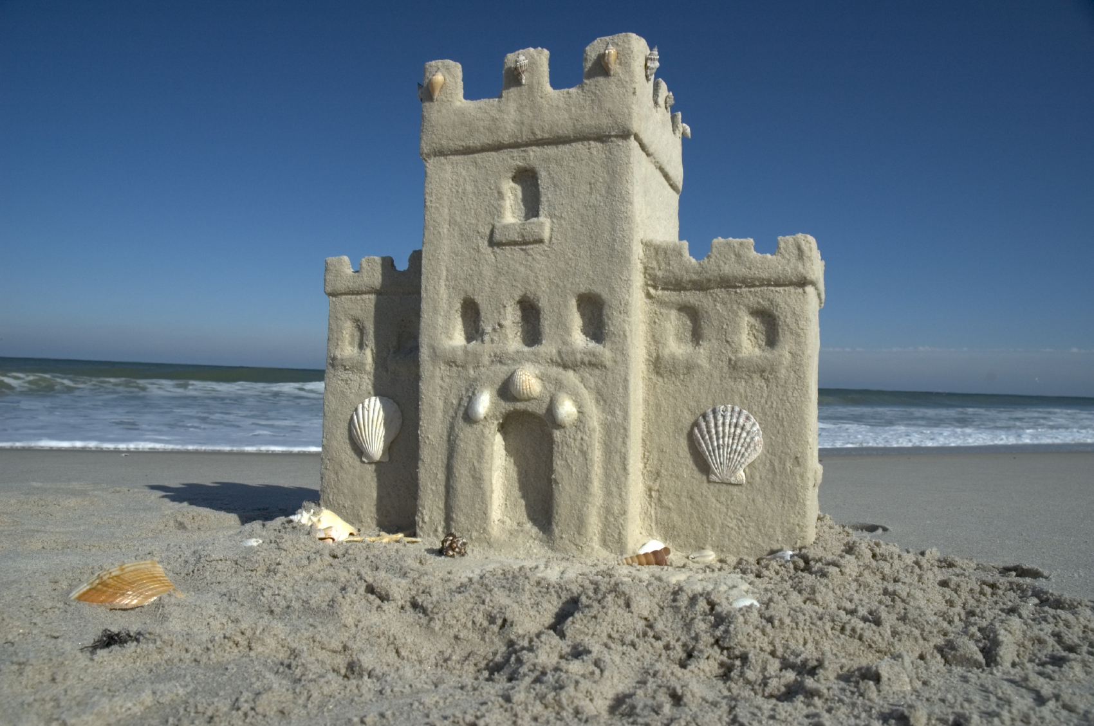

BUY, SELL, OR RENT WITH A LOCAL EXPERT.

2025
MEMBERSHIP DIRECTORY

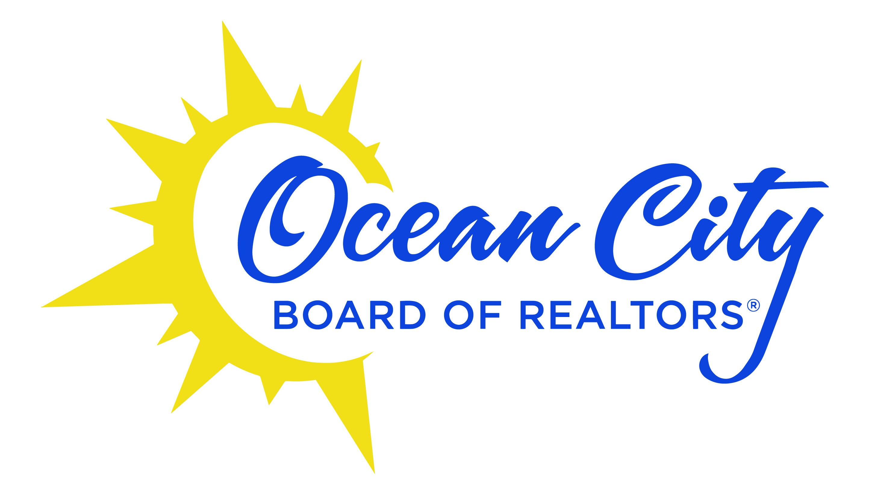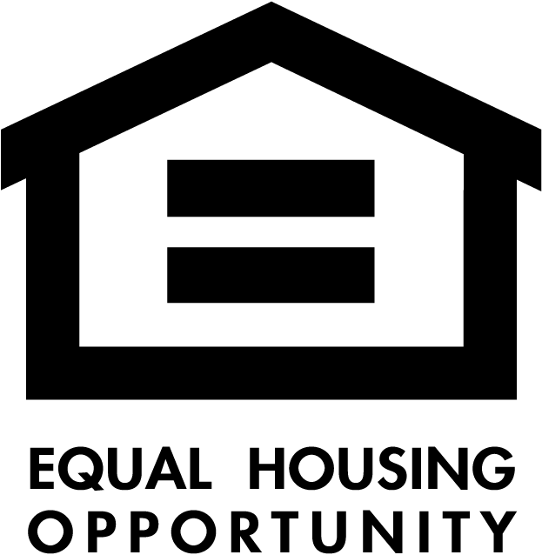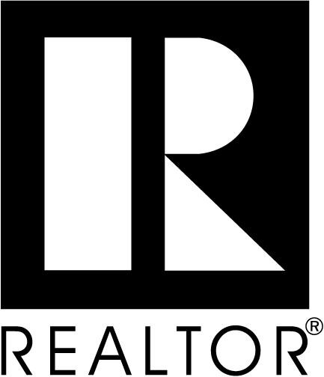
OCEAN CITY BOARD OF REALTORS® ° (609) 399-0128 ° FAX (609) 399-2030 ° www.ocbor.com

AM REALTY ADVISORS 856-470-1066
6 Kings Highway E, Haddonfield, NJ 08033

APEX PRIME REALTY 609-487-9996
6601 Ventnor Ave. , Ventnor, NJ

3DX REAL ESTATE LLC
810 Asbury Ave. (888)304-1447

BERGER REALTY
3160 Asbury Ave. (609) 399-0076
(877) 237-4371
109-55th Street & Haven Avenue (609) 399-4211
(800) 399-3484
1670 Boardwalk (609) 399-2911
(888) 579-0095
1330 Bay Ave. (609) 391-1330
BERKSHIRE HATHAWAY HOME SERVICES, FOX & ROACH REALTORS
901 Simpson Ave. (609) 399-0041
(800) 220-6265 109 34th Street (609) 399-8200
730 West Ave. (609)-957-6787

CA McCANN and SONS
4111 Landis Ave, Ste 1 (609) 263-7422
Sea Isle, NJ 08243

CENTURY 21 ALLIANCE
909 West Ave. www. c21anj.com (609) 399-5711

COLDWELL BANKER REALTY (856) 685-5600
1207 Fayette St.
Conshohocken, PA

COLLINI REAL ESTATE LLC (609) 826-2280
2165 Asbury Avenue, Ocean City NJ
28 E. Landis Ave, Vineland, NJ

COMPASS NEW JERSEY-OCEAN CITY (609) 322-7390
201 34th Street, Ocean City NJ 08226
COPPER HILL REAL ESTATE (267) 535-2660
1819 John F Kennedy Blvd, Ste, Phila., PA 19103

CORCORAN, BAER & MCINTOSH
116 Spring Street in Red Bank, NJ 07701 ( 732) 530-2611

DANIEL R. WHITE REALTOR
524 Station Ave. 856-547-0700
Haddon Heights, NJ 08035

EXP REALTY, LLC (866) 201-6210
28 Valley Road, Montclair, NJ
5009 Landis Ave., Sea Isle, NJ (609)788-3986
1336 Asbury Ave. Unit A, Ocean City, NJ (866) 201-6210

EVERYHOME REALTY INC. (215) 699-5555
PO Box 722
1741 Valley Forge Rd, Worchester, PA 19490

FOX REAL ESTATE
894 Brighton by the Beach (609) 399-0980
3301 Asbury Avenue (609) 398-3636
900 Ocean Ave (609) 399-5377
871 Seventh St. (609) 398-5500
www.foxocnj.com (800) 799-0290
FRIO REALTY GROUP (856) 448-6360
616 South White Horse Pike, Somerdale, NJ 08083

GOLDCOAST SOTHEBY’S INTERNATIONAL
REALTY, INC.
200 34th Street (609) 399-2500
www.goldcoastsir.com (800) 407-4664

GRACE REALTY
1401 Ocean Avenue (609) 398-1776
3400 Central Avenue (609) 398-6200 904 S. Shore Road, Marmora (609) 390-3303 www.gracerealty.com (800) 296-HOME
HOMEGENIUS Real Estate LLC
279 Browertown Road
West Patterson, NJ 07424 (877) 500-1415

KELLER WILLIAMS JERSEY SHORE
903 Bay Avenue (609) 399-5454
www.kwshore.com
KELLER WILLIAMS JERSEY
1000 Haddonfield Berlin Rd, Voorhees (609) 451-6007

KELLER WILLIAMS REAL ESTATE-BLUE BELL, PA
910 Harvest Dr, Ste 100 (215) 646-2900

KELLER WILLIAMS GREATER WEST CHESTER, PA
300 Willowbrook Lane, Ste. 310 (610) 486-6500

LONG & FOSTER REAL ESTATE
14 E 9th Street (609) 398-6762
628 Asbury Ave. Unit A (609) 938-9954
2401 Atlantic Ave (609) 822-3339
Longport, NJ 08403 www.longandfoster.com

MARR AGENCY
2121 Asbury Avenue, P.O. Box 82 (609) 399-7036 www.marragency.coM (877) 399-6277

MONIHAN REALTY
717 Battersea Road (609) 399-1311
(800) 255-1311
3201 Central Avenue (609) 399-0998
www.monihan.com (800) 255-0998

NORTHMARQ ADVISORS, LLC (215) 606-8912
4 Neshaminy Interplex Drive S
Trevose, PA 19053

OCEAN REEF CLUB REALTY
95 Reef Drive (609) 399-8088
www.orcrealty.com
ORCHID REALTY
300 3rd St., Office B
Ocean City, NJ 08226 (609) 399-3361
www.orchidrealtynewjersey.com

REALTY MARK ADVANTAGE
9000 Lincoln Dr East, Ste # 120
Marlton, NJ 08053 (856) 457-4900

RIORDAN REAL ESTATE (609) 263-3235
215 S. Commonwealth Ave. Strathmere, NJ 08248

SETTLE DOWN NJ
34 N. Front St. Phila., PA (215) 920-2116

TNB REALTY, LLC
199 Sixth Ave, Ste C1, (856) 425-2586
Mt Laurel, NJ 08054

VYLLIA HOME
309 Fellowship Rd. Suite 200
Mt. Laurel, NJ (856) 206-0413

WEICHERT REALTORS – THE ASBURY GROUP
660 Asbury Avenue (609) 398-4400
www.weichertattheshore.com

